I love Pizza

Hello! My name is Samuel Tyler. I am a Portuguese boy living in England. I am fourteen years old and I have a sister and a brother. Emily is twelve years old. She is tall and slim. She is an excellent student. Robert, my youngest brother is eight years old. He is genuinely nice, but he is also a bit crazy! He loves sports but he really adores car racing. He is tall and chubby.

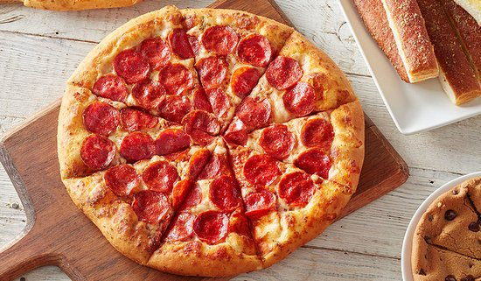I like going to school to meet my friends, but I also like going to school to learn new things especially related to Science. I usually have lunch in the school canteen, but I do not like it very much. You see, I am a fast food fan. I usually bring some pizza or a hamburger or even a hotdog to eat after lunch. I cannot resist fast food, especially pizza. I love the smell of pizza when it is being prepared but more so the taste of the cheese as it melts in my mouth. I always wake up early to go to school. I have breakfast with my family (which is normally pizza for me) and then I walk to school. When it is lunchtime, I am always starving so I need this extra. I am tall and a bit fat, but I do not care because I am happy eating pizza. Yummy! I love pizza!